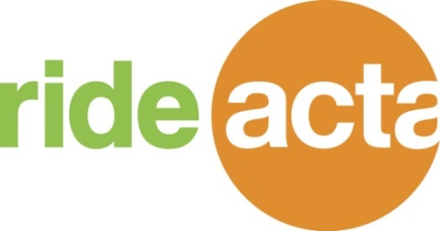
ATTENTION: RIDEACTA SHUTTLE RIDERS
Beginning Sunday November 22, 2015
  - RideACTA Sunday shuttle hours will be expanded. Service will operate from 6:00am – 6:00pm
Beginning Saturday November 28, 2015
  - RideACTA Saturday shuttle hours will be expanded. Service will operate from 6:00am – 11:00pm
Beginning Sunday November 22, 2015
- New FEDEX Clinton schedule. Ask your employer or shuttle driver for the new flyer.
There will be NO RideACTA shuttle service
- Thanksgiving Day / November 26, 2015
- Christmas Day / December 25, 2015
Please remember …
Pay your $.025 as you board the shuttle. Riders not paying a fare will be denied a ride.
- There is no need to call for a ride when you arrive at the IKEA Stop. If the shuttle is not there it will arrive back shortly.
- DO CALL Dispatch IN ADVANCE to schedule your pick–up/ return trip. Last minute calls cannot be fit into the pick-up schedule. Dispatch number is 412-442-4773.
- Be patient, courteous and respectful to dispatchers, drivers
and fellow passengers. Holiday traffic and weather can cause delays.
A new RideACTA Holiday flyer will be distributed in mid-December. This will outline RideACTA shuttle operation through January 3, 2016.

