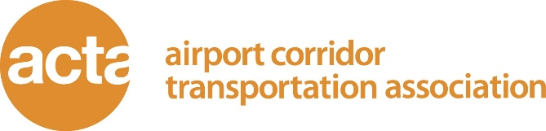

Title: Financial Manager
Reports To: Executive Director
Status: Salaried/Exempt
Start Date: ASAP

General Purpose
The Airport Corridor Transportation Association (ACTA) is seeking a full-time Financial Manager. Under the general supervision of the Executive Director, the successful candidate will manage ACTA’s finances as well as assist in maintaining the overall financial health of the organization. The candidate should exhibit a strong background in accounting policies and procedures.
Duties and Responsibilities
Financial
- Assist in the development of ACTA’s annual budget
- Manage ACTA’s accounts payables and receivables
- Manage and monitor ACTA’s bank accounts as well as handle any bank deposits
- Prepare and gather information for ACTA’s annual audit
- Oversee the preparation of any IRS forms to be filed
- Prepare 1099 forms when necessary
- Prepare and report payroll to payroll service, review payroll documents, track employees paid time off, calculate accrued payroll balances, calculate salary increases and retro pay and prepare monthly timesheets
- Track and document local matching funds for ACTA grants
- Calculate all cost allocations
- Prepare and present monthly financial statements for board meetings including quarterly budget variance reports
- Prepare monthly contract invoices
- Prepare ACTA annual membership dues invoices.
- Prepare daily cash flow sheets
- Transfer funds to maintain cash flow

Grant Management
- Prepare and manage any financial reports (budgets, etc.) for ACTA’s individual grant awards
- Communicate with grant funders on financial questions, issues when needed.
- Ensure that all procurement and DBE grant requirements are met.
Human Resources
- Oversee and manage all ACTA insurance policies (employee and organization based) including submitting premium payments
- Oversee and manage ACTA pension and 403b (TDA) programs including submitting contributions
- Gather data for Unemployment Compensation audit

Administrative
- Answer telephones when necessary
- Manage filing system and keep up to date
- Keep track of office supplies and inventory
- Provide support to other staff as requested
Qualifications
- A bachelor or /associate degree in accounting or business is preferred
- Relevant non-profit organization experience, with an emphasis on accounting, finance, and contract compliance
- Working knowledge of accounting software (preferably QuickBooks), Excel and Word.
- Working knowledge of accounting principles
- Internal audit experience (e.g., contract compliance, internal controls, accounting practices) is a plus
Benefits
ACTA offers the following benefits to full time employees:
- Vacation, sick, personal and holiday time off
- Employer paid SEP pension contribution
- Optional 403b program
- Long- and short-term disability
- Life Insurance
- Dental Insurance
- Vision Insurance
Salary
$45,000-$55,000 commensurate with experience

How to Apply
Email letter of interest and resume to amy.mathieson@actapgh.org

About the Organization
The Airport Corridor Transportation Association (ACTA) is a non-profit Transportation
Management Association supporting and implementing programs that increase travel
options and foster responsible economic growth. ACTA serves businesses, workers, and travelers in the development corridor of the Greater Pittsburgh International Airport in Western Allegheny County. ACTA provides transportation users with information on major transportation issues and travel options to decrease traffic congestion, increase transportation access and mobility, and to promote the use of transportation alternatives to the automobile. ACTA operates the RideACTA shuttle service as a last-mile transit option. The shuttle serves locations within a 1.5 mile radius of the IKEA bus stop in the Robinson Township commercial area.

